Arborescence du site
- Home
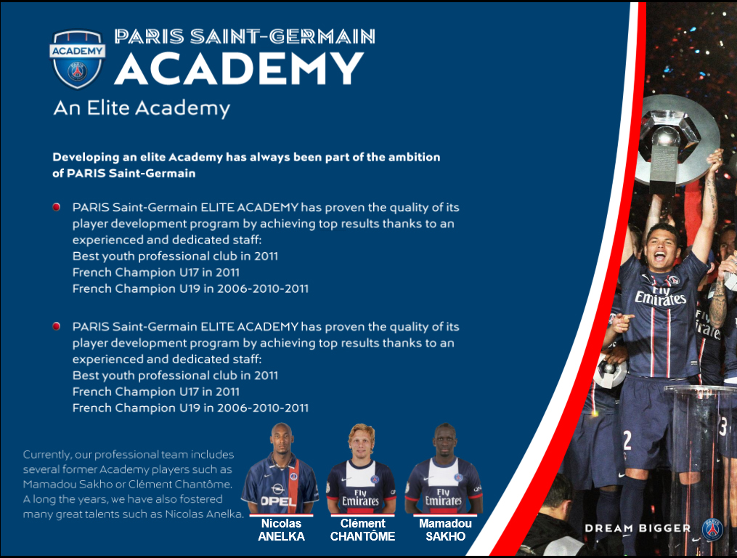
  - The PSG experience


    - An elite academy
    - Legendary players
    - International talented players


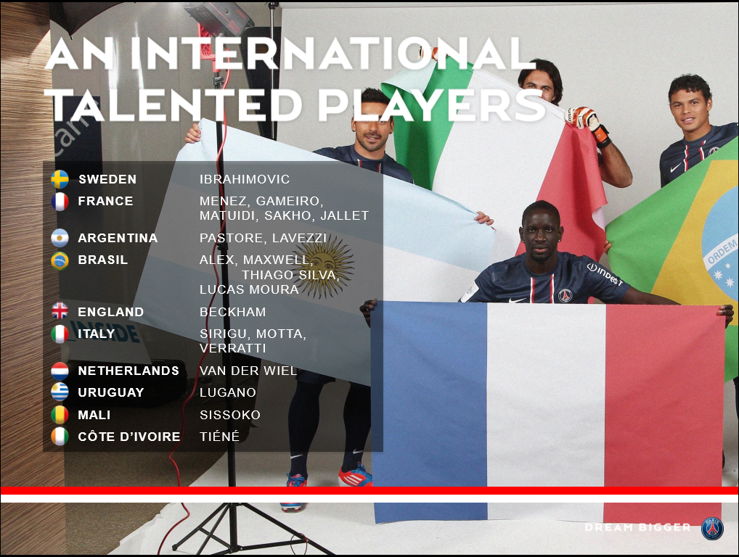

    - Europe elites
  - Contact us
- About us
  - Our project
Sur la même page l’ordre peut être changé
  - Our director
  - Our added value
  - Our coaching method
- Camps
  - Camps info
  - Camps locations
- Gallery
- Register now
- Boutique

