

Yanbu Industrial college

Department of Mechanical Engineering
Technology

Cooperative Training Report
(MET 310)

Saudi Electricity Company



Prepared By

Mohammed Sameer Mahrous

ID: 312101

Supervised By

Mohammed Kasmuri

Semester 2, 2014-15

Acknowledgement

First of all, I would like to acknowledgement with deep appreciation to Allah for helping me and give me the strength to complete my final report and finishing all my courses successfully.

I own particular thank to Yanbu Industrial collage and it's Industrial Affairs Department for all the support.

It's also my duty to record my thankfulness to coop training coordinators in Mechanical Department specially to Eng. Mohammed Sarwar Pasha and all of Mechanical Engineering Department teachers.

I am also grateful to the "SCECO" Saudi Electric Company for their undying support during my training period. A great and special thank to my supervisor Eng. Mohammed Mansour who helped me and guided me in all my works as a trainee. He did his best with me by helping me and answering my questions during training time.

In addition, A thank to my Coop training advisor for his guidance through the Co-op training period and also for his advised recording the report which I'm writing right now.

Finally, I take this chance to thank my parents for all their support through my educational years.
Once again, I thank all the people which have encourage, helped and support me.

Table of Content
Chapter 1 Page
(Introduction)
1.1 About the company……………………………………………………………………. 7
1.2 The Power plant contains…………………………………………………………… 8
1.3 Purpose of the company…………………………………………………………….. 11
1.4 Power plant departments…………………………………………………………… 12
Chapter 2
2.1 Five stars program…………………………………………………………………….. 15
2.2 Evacuation area…………………………………………………………………………. 15
2.3 firefighting system…………………………………………………………………….. 17
2.4 Smoking area…………………………………………………………………………….. 19
2.5 Wearing PPE……………………………………………………………………………… 20
Chapter3
3.1 Black start…………………………………………………………………….............. 25
3.2 Fuel oil unloading system…………………………………………………………. 26
3.3 Gagging system………………………………………………………………………… 28
3.4 Gas turbine……………………………………………………………………………… 30
3.4.1 GE unit……………………………………………………….…………. 35
3.4.2 ABB unit………………………………………………………………... 37
3.5 Maintenance of gas turbine……………………………………………………… 39

Chapter4
4.1 Alignment basics……………………………………………………………………… 44
4.2 Sealing…………………………………………………………………………………….. 47

Chapter5
5.1 Conclusion………………………………………………………………………………. 51

Introduction :

Yanbu Industrial College represented by department of mechanical engineering give an opportunity to their student to spend three and a half months (14weeks) in any industrial companies. My coop-training program started at February 1, 2015 in Saudi Electricity Company (SEC) in western region for three months and a half at Madinah power plants.
The training program gives the student a chance to use his knowledge from what he has studied and apply it in the real industry. In addition, it can improve his teamwork skill and communication skill with engineers in the industrial fields. During my coop training, I worked in maintenance and operation department.
In this report, I will give a brief description about what I have learned from my three and a half months of training in Madinah power plant in general and I will go deeply with the details.

Chapter 1

Introduction

  - About The Company :

Power plant (power station) is an area where we can use different types of energy sources to generate electricity. Here in Madinah the SEC has two power plant. The first one is Abiar Ali Power Plant "PP1" and the other one which we are in is Airport road Power Plant "PP2".

Madinah second power plant "PP2" consists of seven (7) gas turbines with total capacity of 245 MW. It was established in 1976 with two (2) units. Five (5) of these units are manufactured, designed and installed by Asian Brown Boveri (ABB) company. Three of them are AAB type- 9D with capacity of 15 MW of each and the rest two units are ABB type -11D5 with total capacity of 90 MW(each one can produce 45 MW). In 1995, another big and one of the famous companies in the world in gas turbines manufacturing had come. But this time from the United States, which is the general electric or "GE". The "GE" had installed two more gas turbines to the station. Their type is "Frame 7EA" with total capacity of almost 120MW (60 MW for each).

  - The Power Plant Contains:
- Seven gas turbines
2GE units, 5 ABB units.
Medina power plant

Unit | Manufacturer | Compressor stages | Turbine stages | Capacity(MW) | Shaft speed
GT-1 | ABB-9 | 17 | 4 | 20 | 4486
GT-2 | ABB-9 | 17 | 4 | 20 | 4486
GT-5 | ABB-9 | 17 | 4 | 20 | 4486
GT-6 | ABB-11 | 17 | 5 | 50 | 3600
GT-7 | ABB-11 | 17 | 5 | 50 | 3600
GT-8 | GE-7EA | 17 | 3 | 60 | 3600
GT-9 | GE-7EA | 17 | 3 | 60 | 3600

- 9 transformers.
- Control building.

- 12 fuel tanks:
There are 12 tanks in "PP2" and the fuel that is used here is the Diesel. The tanks are arranged as; from No.1 to 9 their capacity is 1.8 million liter. And from 10 to 12 their capacity is almost 4.7 million liter.by the way, the tanks 10, 11 and 12 were established five years ago with the extension of the power plant.

Tank# | Tank Capacity | Roof Type | Diameter | Height
Tank# | (KL) | Roof Type | (M) | (M)
1 | 1820 | Fixed | 13 | 14.5
2 | 1820 | Fixed | 13 | 14.5
3 | 1820 | Fixed | 13 | 14.5
4 | 1820 | Fixed | 13 | 14.5
5 | 1820 | Fixed | 13 | 14.5
6 | 1820 | Fixed | 13 | 14.5
7 | 1820 | Fixed | 13 | 14.5
8 | 1820 | Fixed | 13 | 14.5
9 | 1820 | Fixed | 13 | 14.5
10 | 4748 | Fixed | 21 | 14.5
11 | 4748 | Fixed | 21 | 14.5
12 | 4748 | Fixed | 21 | 14.5
Total | 30624

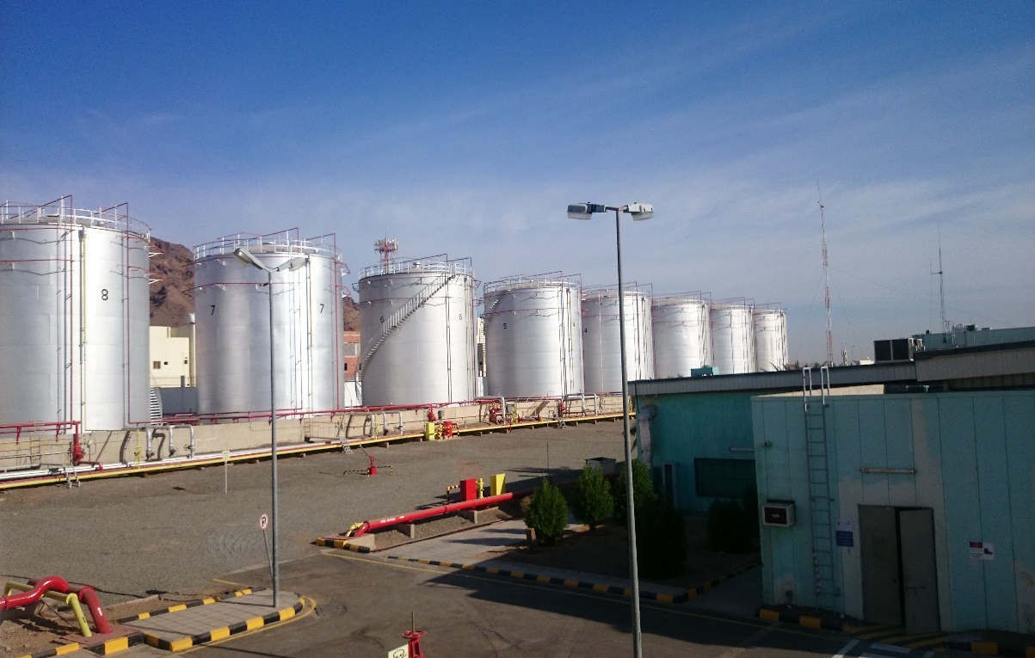
Fig. fuel tanks
- Mechanical Workshop.

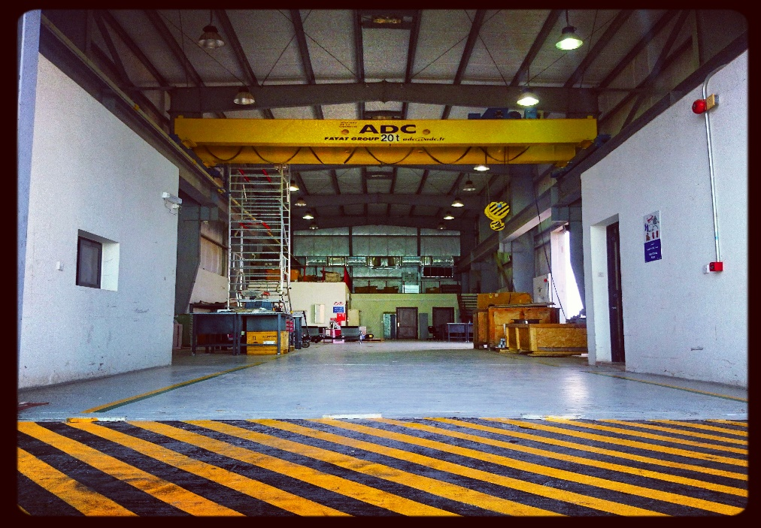
Fig. mechanical workshop
- Electrical Workshop.
- Warehouse.
- Laboratory.

  - The Purpose of the Company:

  - Take part and invest in electric power generation, transmission and distribution projects outside and inside Saudi Arabia.

  - Export and import electric power across Saudi Arabia’s borders.

  - Generate, transmit and distribute electric energy in the Kingdom.

  - Purchase, sale and provide electric energy services in the Kingdom.

  - Power Plant Departments:

- Maintenance departments:

This department is responsible for performing the mechanical maintenance activity such as repair, reinstallation and diagnosis for gas turbine unit's parts or its auxiliary system such as valves and pumps to get higher power generation. In addition, coordinate with the material section to supply the power plant with material needed for maintenance for one year. Implement all type of mechanical maintenance program such as preventive maintenance, corrective maintenance and overhaul inspection for the units or its auxiliary system. Moreover, plan for inspection checks for gas turbine to find any technical fault and fix it to prevent any power failure.

- Operation department:

This section is responsible for safe and economic operation for all the gas turbine units and monitoring the unit to insure it works properly. Also, monitor the level of diesel fuel tanks in power plant and coordinates with fuel suppliers to supply the power plant with sufficient fuel. Moreover, it responsible for writing work orders and coordinate with the maintenance department in order to address the problem that occur in the unit or its accessory.

- Technical support section:

Responsible for engineering services function of the power plant to provide the necessary support to all sections and departments in the power plant. Also, it is responsible for preparing the maintenance planning such as plan for all inspection by providing the necessary equipment in order to perfume necessary maintenance. In addition, coordinate with other departments to insure the availability of materials and manpower for all maintenance jobs.

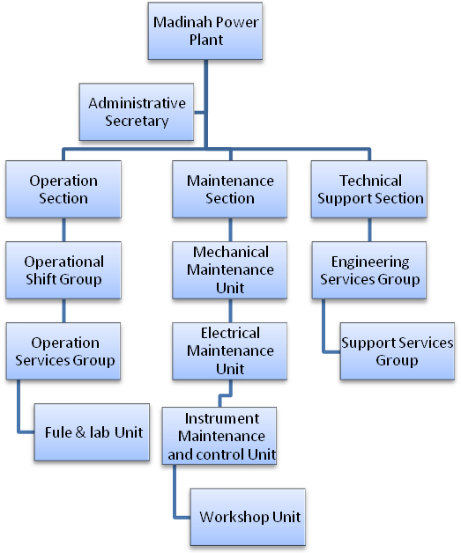

Chapter 2

Safety

The program in first week was scheduled as a safety week, we have been taught the main safety rules and the safety precautions which must be taken in this company. We have been known first about the safety rules at the beginning in general such as evacuation area, smoking area, firefighting department, wearing Personal Protective Equipment, the signs and symbols, the paints of the pipes and what does each color means, the five stars program and ets. Then we went deeply about everything.

2.1 Five Stars Program:
Saudi Electricity Company applies their safety administration program which is called "Five Stars Program" to minimize and decrease the possibilities of happening the accidents and the injuries of the workers and decrease them as much as possible. By the way, all companies all over the world take the safety in their consideration or just like they say "SAFETY FIRST ALWAYS".

2.2 Evacuation Area:
-It is an assembly area which must be outside the buildings. It must be also at least 50 ft. away from the buildings and should has sufficient space to accommodate all the employees, workers and visitors.
-If any emergency happened, everybody must leave everything, go immediately to the evacuation area and then call the firefighting department to deal with the situation.
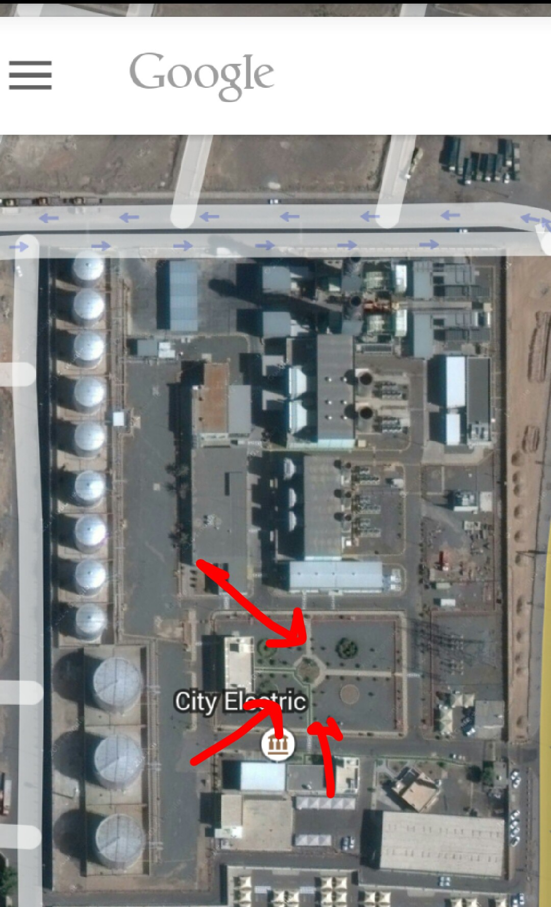

Fig. Evacuation area

2.3 Firefighting System:
There are many hazards that are facing many engineers or technicians in the power plant. One of the most hazards that could occur in power plant is fires or explosion of fuel storage tanks and combustion chambers which are used to operate the gas turbine. However, I will give a brief description about the types of fire system that are being used in the power plant.

- Foam System:
The foam is coming from the pump room. They mix the water with the soap to make the foam be ready to flow inside the yellow pipes. The other type is the pure water, which is flowing inside the red pipes. The function of the pure water is the Cooling while the foam is for extinguishing the fire. In addition, the foam isolate the diesel from the atmosphere so that there will be no enough Oxygen to start any fire.

- Co2 System:

This type of system is mainly used to protect the gas turbine unit component and the generator by reducing the level of oxygen in the air which is equal to 21% to the level 15% which will not cause any combustion. The fire protection system used the piping to transfer the low pressure carbon dioxide co2 from the tank to gas turbine room when the fire concurs. The storage tank is located in safe place in the site and near the gas turbine room. Also, the co2 is maintain a saturated liquid in the storage tank at pressure of 300pisg (2069kpa) and temperature of 0 F(-18C).

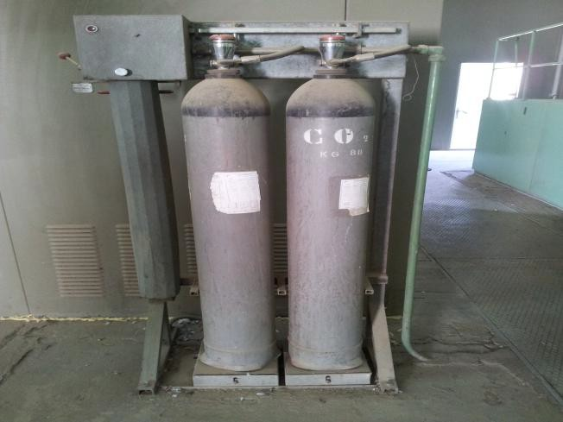

Fig. CO2 system.

2.4 Smoking Area:

The smoking is not allowed inside the buildings and the company facilities but there are more than one smoking area which are as following:
- In front of the administration building.
- In front of the firefighting department.
- In front of the laboratory.
- In front of the mechanical workshop.

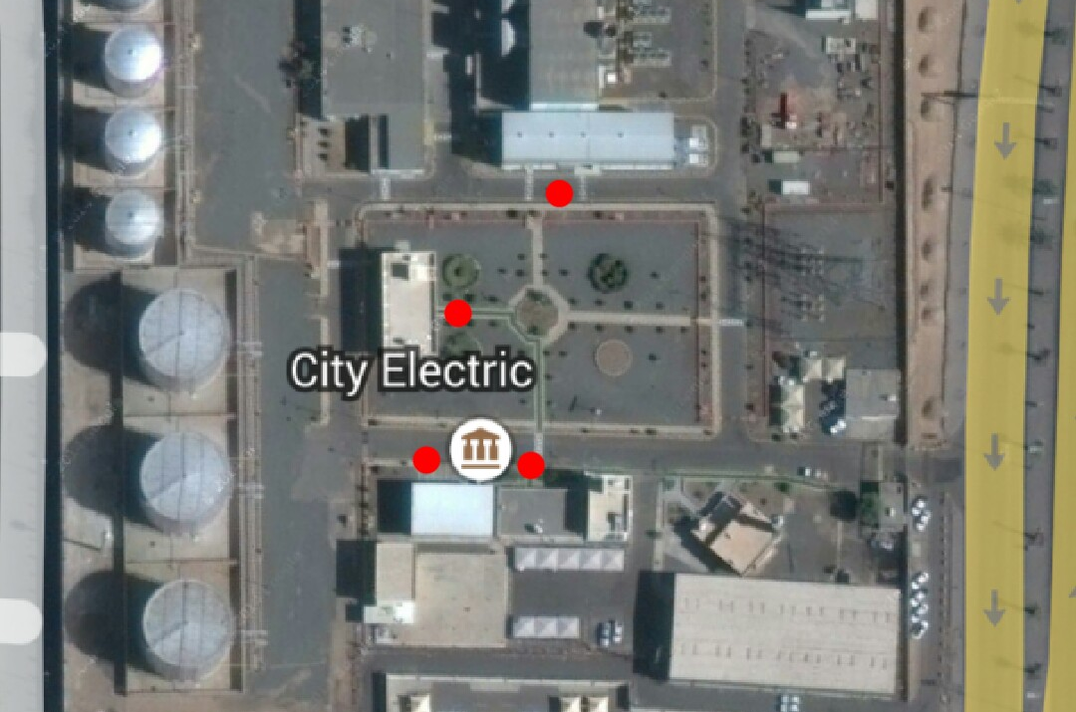
Fig. smoking areas

2.5 Wearing PPE:
- It is the equipment which you are wear in the work to protect your body against the risks.
- The Personal Protective Equipment must be worn and they will be depended on the place which you are in.
- Always wear safety shoes instead of regular, sport and formal shoes!
- Always wear the company uniform, do not wear a thoab!
- Wear the safety robe during working in high positions.

- Safety Shoes:
The main function of them to protect your foot from hazard. They are made from special tough materials and good quality leather.
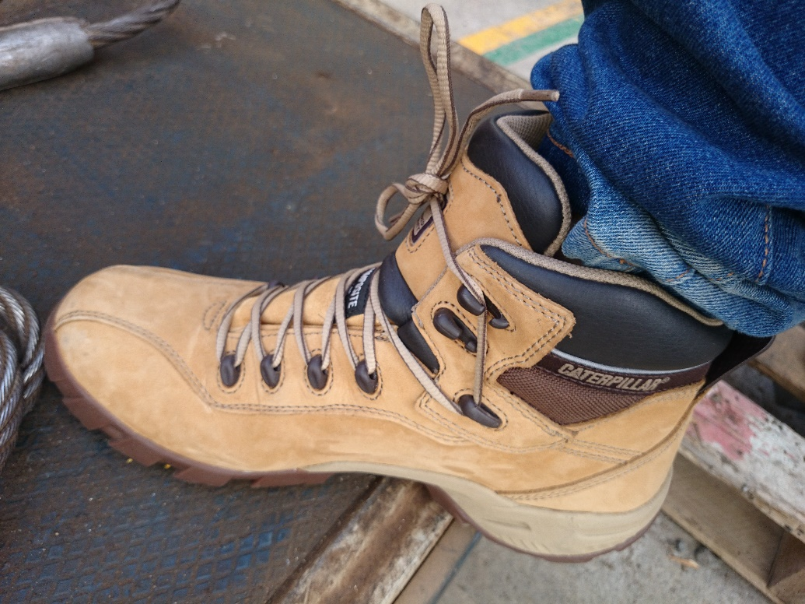 Fig. safety shoes
- Helmet (Hard Hat)
The function of it to protect the head from injuries. You must wear it at work.
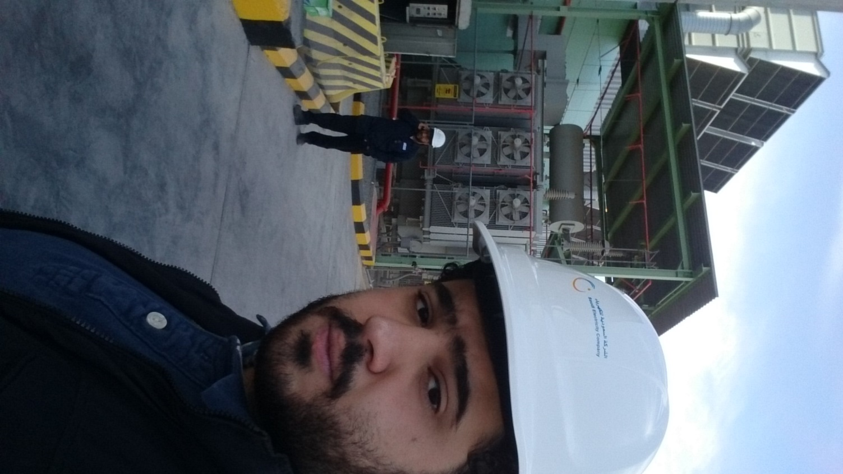 Fig. Me,wearing the Helmet

- Gloves:
They are important to protect the hands.there are many types of gloves and each type is suitable for different type pf works.each type are made from different material such as leather, rupper, and plastic.


Fig. leather gloves

- Protictive Clothing:
The uniform that the company gave it to us can protect the whole body from fire and hazard.

Chapter 3

Madina Power Plant
Machinery

  - Black Start:

Each power plant required an electrical source to operate the gas turbine units under normal condition. This electrical source comes from the distribution system or network. However under emergency condition the power plant takes electricity from black start diesels generator. Black start diesels engine is used to restore the power supply to the power plant and then the electrical power can be generate by using gas turbine units. Black start engine can be operation by taking the power supply from group of battery located in sites to operate V12 cylinder diesel engines.

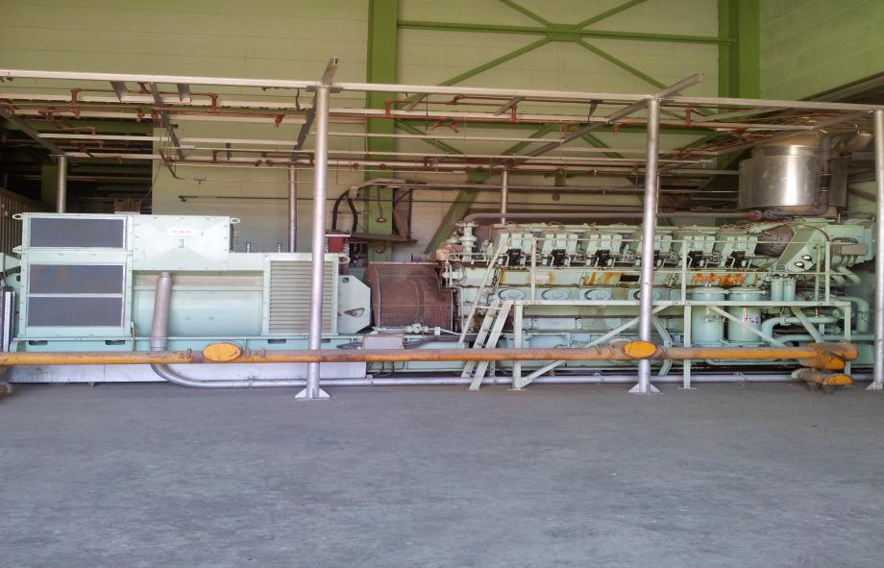
Fig .Black Start

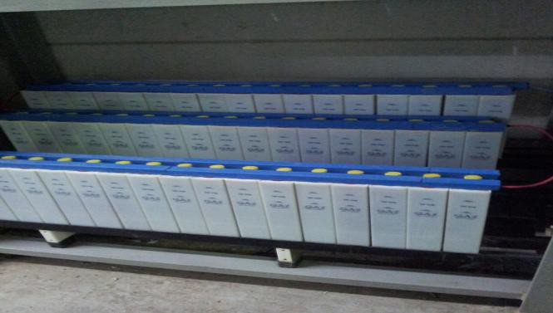
Fig. Group of Battery for operation the black start generator

  - Fuel Oil Unloading System:

In Medina power plant, the main source of fuel system is diesel fuel provided by trucks from Saudi Aram-co Company and unloaded at heavy bulk stages tanks. This type of fuel is used to operate heavy duty gas turbines.
Station;
The fuel unloading station is used to unload diesel truck and transfer the fuel to the gas turbine units through the use of pumps, pipes and valves. The diesel unloading area is located in a safe place near the storage tanks and far away from turbine hall. Also, it was built in incline area in order to unload the whole entire diesel fuel from trucks. There is only one unloading station in medina power plant and it has four skids where the diesel trucks could unload the fuel. In addition to that, there is two bay in the station consisting of two arms and connected to such as air eliminator, valves, fitting and pumps.

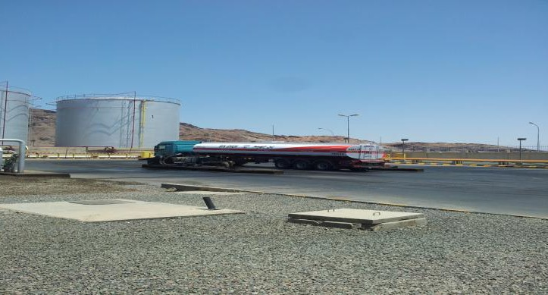

Fig. Fuel Unloading station.

- Procedure for unloading diesel fuel:-

1) Operator should check the truck according to a power plant regulation
2) Connect the ground cable between truck and valve body
3) Diesel unloading pump started manually
4) Operator shall put the tank being unloading in services by open the tank valve
5) The operator have to remove the air from the pipes in order to avoid unloading pump cavitation.

Fig. Pipes connect to tanks

3.3 Gagging systems:
- Float and tape gage:

This type of gage usually called'' Automatic Tank Gages'' and it was introduce in 1930. This gage is used to measure the level of the fuel inside the tank by raising or lowering the float steel. The major component of this gage is spring, transmitter and pulleys.
The float is connected to a spring by using perforated tape to balance the steel float. The accuracy of this gage is about (10mm). The biggest disadvantage of this gage on driven instrument is the sudden movement of the drive mechanism because of the turbulent of the fuel or liquid.
This gage is located outside the shell of the tank with indicator screen. Also, the operator can read the level of the diesel fuel from the control room.

Fig. Float and Tape Tank Gage

Fig. Floating and Tape Gage

3.4 Gas Turbine Unit:

Gas turbine is a combustion engine that uses a diesel fuel to produce energy and operate as simple brayton cycle. Medina power plant has 7 gas turbine units, some of them are indoors and the others are indoors which are used to produce electricity. Each gas turbine units have six major components such as air inlet, compressor, combustion chamber, turbine, exhaust and support systems. Turbine and compressor are connected by single shaft and it is supported by 5 lubrication journal bearings.

How does gas turbine works

Gas turbine is operating by entering a fresh air falling vertically through a filter air duct. Then the air is compressed into high pressure throw axial flow compressor. After that, diesel fuel added to the compressed air and burned inside the combustion chamber which will raise the energy level. Then these hot gasses which have high pressure and temperature are moving to an expansion turbine that will convert the air energy into a mechanical energy to rotate the shaft. Finally, some of the hot gases go to the exhaust diffuser and send to the atmosphere through a diffuser stack.

- Gas turbine component:
- Air inlet:

Is a duct with rectangular shape is use to guide the ambient air to inter the compressor and it has a filtration to filter the air from sand.

Fig, air duct and filter
- Turbine:

All turbines in medina power plant have number of stages some of them have three stages, four stages and five stages. These stages are used to produce a useful mechanical energy to rotate the shaft by converting the kinetic energy of hot gases. Every stage consists of number of nozzles and number of blades (bucket). These blades are absorbed the energy from the hot gases and converted it into rotational energy to rotate the shaft. The rotting of shaft is used to rotate the generator rotor so that it generates electricity.
- Compressor:

Same as turbine the compressor has many stages and consist of compressor casing and rotor. Inside the casing there is inlet guide vane, rotor and stationary blades. The inlet guide vane control the amount of the air that inter into the compressor by changing it positions. The rotor blade is used to compress the air in each stage and the stator blade directs the air to enter the next stages by changing its direction to proper one. Some of the air leave the compressor casing and go to the combustion chamber while the remaining air leave the compressor and it use to cool the turbine and the bearings.
- Exhaust:

After the hot gasses takes place in the turbine some the hot gases send to the atmosphere through the diffuser and then leave from the exhaust.
- Combustion chamber

The function of the combustion chamber is to burn the diesel fuel and transfer the hot gasses which have high pressure and temperature to the turbine. GE Frame 7EI gas turbine has ten 10 combustion chamber arranged around the periphery of the compressor discharge. However, the ABB gas turbine has only one large combustion chamber. Also, this system includes fuel nozzles spark plug and flame detector.

- Gas turbine auxiliary system:
Starting system:

Before the gas turbine reach its final speed, the starting must be used to rotate the shaft from standstill and continue for rotating. In addition, it is used to cool the shaft after shutdown the unit by rotating the shaft at low speed. This system has three major components, starting motor, torque convertor with hydraulic ratchet. The motor is used to drive the shaft from standstill.
Fig. Staring System

- Atomizing air system:
After the fuel splash into combustion chamber through a nozzle there will be a formation of fuel droplet. This droplet cannot burn completely so the atomizing air system is used to atomize these droplets by lower the pressure of fue

- Cooling system:
This system is very useful to protect mechanical equipments from any damage which occur due to high temperature. Cooling system is used to cool different devise such as, generator heat exchanger, lube oil system and atomizing air. For example, for
lubrication oil system the two shells and tube heat exchanger are used for this
purpose. One of them should be in the service while the other is standby

- Operation of gas turbine unit:
Medina power plant has two type of gas turbine unit GE and ABB. Due to the manufacturer different company they will have different methods of operation. However, both of them can be operated manually or automatically from the control rooms.

3.4.1 GE unit operation system:

In operating GE gas turbine units the operator should check the unit before the stat up and during the initial operations to make sure there is no abnormality lead to failure during start up also to ensure that the unit will start smoothly without any problem.

- Check before operation:

There number of equipments or tools shall be checked before operation to get higher
power and to safe the machine from any consequence damage that could happen if the operators do not check the unit. First one, all the piping system such as lube oil piping, water piping and diesel fuel piping should be check to insure that there is no visible leakage or any damage in the pipes. Second things, the technicians have to check the auxiliary systems such as fuel forwarding pump and water pump to see is
there any leakage, vibrations of the machine and the high temperature of pumps. In addition, the cooling water system such as heat exchanger has to be check and filled with proper coolant. Finally, check the gas cylinders that are needed for starting the ignitions.

- Checks during the start up:

A Crank:
Check the turbine and gear box compartments to listen are there any noises. Also check for any vibration in the gear box compartments
B- Fire:
Check the area that surrounded the fuel nozzle and the fuel filter. Also, Check the fuel check valve and fuel piping for any leakage.

Operation of GE gas turbine:

To operate the GE units the operators use the computer to run the unit through program called Mark5. The control display contain many but the main is
Off: This option mean that the unit is under standby condition and at this condition the crank shaft is rotate at very low speed (10rpm)
Crank: This option is used to accelerate the unit from 10rpm to 800rpm. Also it can be used when one of the following cases occurs:
1) in the case of maintenance the operation used this option to cool down the unit so that he can inter the turbine compartment
2) also in the case of combustion flame out the diesel fuel may stay in combustion chamber and when the unit start up agine the explosion will occur so the operator select this option to extract the fuel that don not burn.
Fire: the operator selects this option to allow the unit reaches the combustion process
Auto: this option will do all the previous steps till the unit reach full speed no load.
Operation steps:
1-From the control display master select select Auto.
2-from master control select start.
3- Then gas turbine auxiliary system will start such as lube oil pump to lubricate a bearings and other equipment.
4- The turbine shaft will rotate and accelerate until the unit reaches 10rpm. After that the turning devise will stop.
5-finally, the turbine shaft will rotate till it reaches 60%from its final speed. Then the starting motor will stop and the turbine will continue to rotate by itself with full speed no load.



Off


Crank

Fire

Auto

3.4.2 ABB Unit Operation system

The operation of ABB Units is different than the operation of GE units. ABB unit operate manually while GE unit operate automatically by using computer. Also, the ABB required 8 steps to operate but GE has only three steps such as crank, fire and auto.

Procedure for operating ABB Gas turbine:
For operating the ABB gas turbine the operator have to select each step from 1-8 to start the unit and from 9-11 to stop the units. By pressing these buttons they will send a signal to the control panel for each component to do the corresponding function
Step1:
At this step,
- The lube oil pump starts to lubricate all the bearings.
- The fuel transfer pumps switch on and the valve of fuel tank will open.
Step2:
- Torque convertor switch on
- Maine fuel oil pump switch on
Step 3:
- Starting motor switch on to rotate the shaft
- Turbine rotor start turning
- Torque convertor will be filled with oil
- 530(14.7%) rpm
Step4:
- Solenoid valve is open
- Ignition pilot flame switch on
- The cooler fan motor of lube oil switch on
After the unit speed reach 720(20%) rpm go to step 5
Step 5:
- Ignition pilot flame switch off
- Fuel valve open to permit the fuel to go to nozzle and start ignition.
- Unit speed reaches 950 rpm (26.4%)
Step 6:
- Cooling water pump for the generator switch on
- The speed of turbine will reach 2400(66.7%) rpm by using the starting motor
Step 7:
- Starting motor switch off and the turbine will continue acceleration
- Lube oil cooler fan switch on
- 3500 rpm
Step 8:
- Auxiliary lube oil pump switch off
- Excitation is switch on and generate voltage build up
- At this step the unit will reach 100% rpm of its final speed (full speed no load).

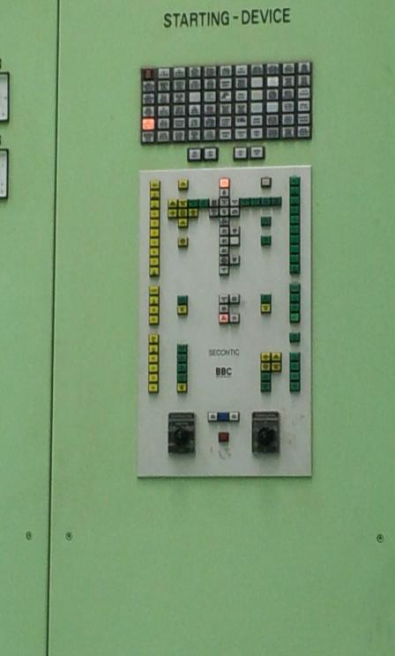
Fig. Starting Device for AAB Unit

3.4.3 Maintenance of gas turbine:

There are two types of maintenance, preventive maintenance and corrective maintenance. The preventative maintenance is a series of planned activity to ensure a reliable operation of gas turbine. For example, all inspection in the gas turbine is consider as a preventative maintenance since it performs after number of operation hours However, the corrective maintenance is unplanned maintenance carried out on emergency basis for repair or replaces the damage part.

Gas turbine inspection:

Any gas turbine units are required number of planned inspections by repair and replace the damage parts to insure the safety of the units from any problem and to make sure it will operate with its maximum efficiency. These number of inspection can be reduce maintenance cost and reduce the number of power outages. There are two types of inspections, running and shutdown inspection. The running inspection is done when the unit is under operation condition. However, the shutdown inspection is done at standstill condition and it has three types such as hot gas, combustion and major inspection.

Hot gas inspection (HGPI)

This inspection is considered as medium maintenance. All the parts that have been replaced in the CI must be changed in HGPI. When the turbine fired hour's reach1600, the hot gas inspection is required to perform the combustion inspection and inspection the turbine nozzles and turbine buckets.

Combustion inspection (CI)

Combustion inspection also called light maintenance because it performs after a few hours of operations. Usually, this inspection is done after 6000hours to 8000hours of operation. In this inspection the most part that have to be replaced or repaired is fuel nozzle should be changed and the combustion liner.

Major inspection

Involve partially disassembly to inspect all the components and detect the damage or worn parts and replaced it. Also, in this inspection all that parts in HGPI and CI must be replaced in this inspection. For example, the crack in the casing of turbine should be checked. In addition, the blade of turbine and compressor should be checked for cracking.

Type of Inspection | Intervals | Duration
Major inspection(MI) | 24000 – 32000 fired hour | 12 weeks
Hot path inspection(HGPI) | 12000 – 16000 fired hour | 6 weeks
Combustion inspection(CI) | 6000 - 8000 fired hours | 4 weeks

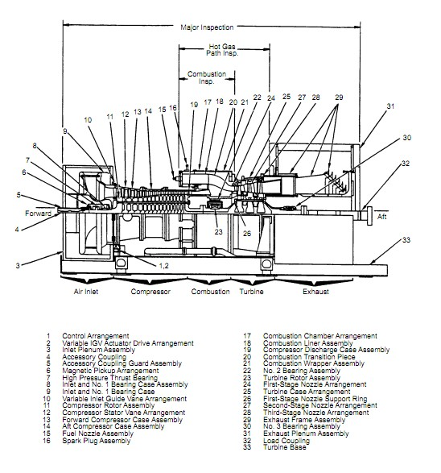

Fig. major inspection

Case Study
Unit was carrying alarm and suddenly tripped with following alarm
1- Combustion flame out
2- Flame monitor trouble alarm
Procedure carried out by plant engineer after trip:
Operation
1 operator check the machine locally for abnormality
2 emergency work order issued for maintenance staff

Maintenance
1- Maintenance staffs check any blockage in fuel oil lines by opening and closing related valves.
2- Fuel oil line pressurized till the fuel oil skid of the machine
3- Check the line from counter meter till fuel pump but the presser found zero
and upon checking this portion, solenoid valves found in closed position.
4- Maintenance staff instrument section replace the damage solenoid valve and then the unit started again with full speed no loads.

Chapter 4

Engineering fundementals

4.1 Alignment basics
- Misalignment:

It is a condition where the rotating centerlines of two or more machinery shafts are not in line with each other.
- Types of misalignment :
- Parallel Misalignment.
- Angular Misalignment.
- Combination Misalignment.
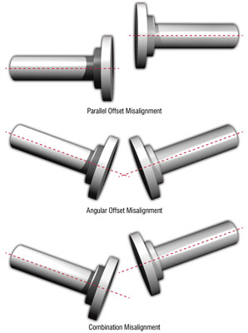 Fig. Type of misalignment

- Alignment methods:

- Using straight edge and feeler gauges.

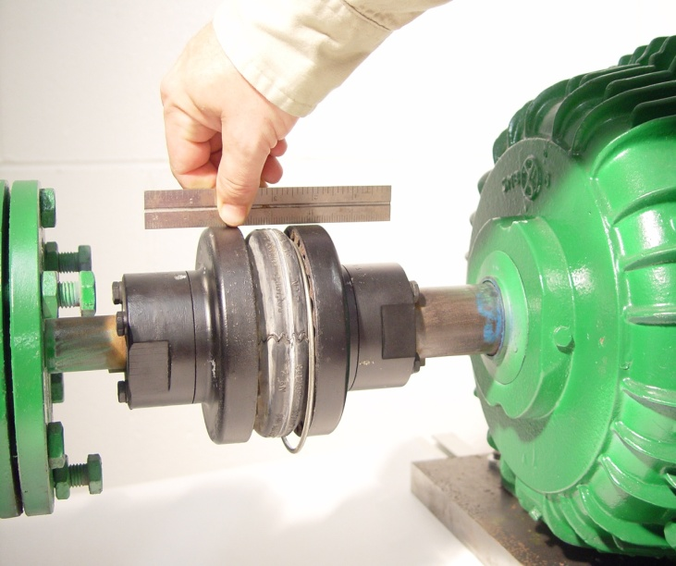
Fig Straight edge

- Using dial indicators.

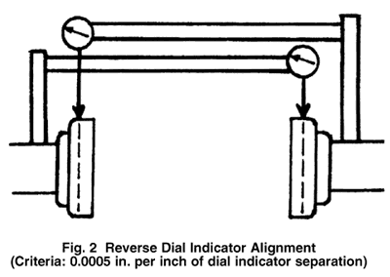
Fig : Dial indicator

- Using laser alignment.

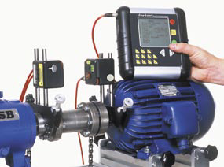
Fig: Laser alignment

- Misalignment symptoms :

- Increase the temperature near the bearing.
- Shaft is broken.
- Lubricant leakage.
- Broken bolts coupling.
- Loose foundation bolts.
- bearing, seal, shaft, or coupling failures.

- Benefits of alignment:

- Increase availability.
- Increase productivity.
- Increase life time .
- Lower operation cost.

4.2 Sealing:
- Function of seals:
Seal are used to prevent the leakage of liquid, solid, and gases from items of rotating machinery.
- Types of seals:
- Static seal:

It is used for sealing surfaces between which there is no relative motion .
Examples of static seals:
- Gasket.
- O-ring.
- Sealant.

- Dynamic seal:

It is used for sealing surfaces between which there is relative motion.

Examples of dynamic seals:
- Packing seals.
- Lip seals.
- Bushings seals.
- Labyrinth seals.

- Gasket
It is a mechanical seal which fills the space between two or more mating surfaces, generally to prevent leakage from or into the joined objects while under compression.
Gasket materials:
- Paper.
- Cork.
- Rubber.
- Plastics.
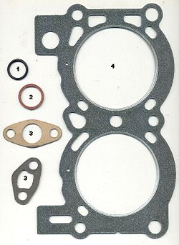
2.13 Gasket

Chapter 5

Conclusion

5.1 conclusion:

In Conclusion, the coop preparing was an educational and very helpful experience I picked up from my work in this organization. I have figured out how to chip away at Gas Turbine and how to work it. I additionally figured out how to act a direction from my manager and tailed it truly. In the co-agent preparing project, I realize numerous things, which are valuable and supportive for future. I delighted in my work in SAUDI ELECTRICITY COMPENY.I found new things, met new individuals and expanded my insight by talk and thoughts. I prescribe any understudy to prepare in SAUDI ELECTRICTY COMPANY in light of the fact that he will advantages later on.

- References:

- Information sheets in Mechanical Department at YIC:
PLANT MAINTENANCE; MET 105, 2011
EQUIPMENT MAINTENANCE; MET 213, 2011
- Saudi Electricity Company Document.

- Saudi Electricity Company employees.

- ABB website.

- General Electric website.

