Luca Cremascoli
Personal Information | Contact Information
Date of birth: 27/04/1995  Country of birth: Italy  Nationality: Italian | Mobile IT: +39 334 147 6673  luca.cremascoli@alumni.esade.edu
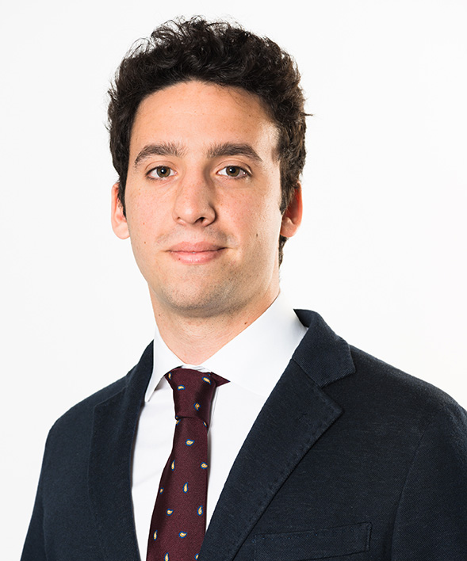
 |  |  |  | Education
ESADE Business School, Ramon Llull University |  |  |  |  |  |  |  |  |  |  | Barcelona, Spain
Bachelor in Business Administration (BBA) & MIM + CEMS class of 2018/19 |  |  |  |  |  |  |  |  |  |  | 09/14-06/19
City University of Hong Kong  Exchange Program |  |  |  |  |  |  |  |  |  |  | Hong Kong, China  01/18-06/18
Istituto Gonzaga  Liceo Scientifico (High School). Exchange program in Queensland, Australia (07/12-12/12) |  |  |  |  |  |  |  |  |  |  | Milan, Italy  09/09-06/14
St. Louis School of Milan  Middle School (Double Program: British & Italian) |  |  |  |  |  |  |  |  |  |  | Milan, Italy  09/06-06/09
 |  |  | Work Experience
McCann Worldgroup |  |  |  |  |  |  |  |  |  |  |  |  | Milan, Italy
Worldwide Advertising agency (present in +100 countries); $11bn yearly revenue 2017; +21k employees |  |  |  |  |  |  |  |  |  |  |  |  | 09/17- 12/17
Account Manager Intern
- Managed communication and relations within internal departments (Creative & Planners).
- Handled contacts with clients & assisted client’s communication and new business strategies.
- Assisted to the process of creation of an advertising campaign, market and competitive analysis.
Instituto Roncalli – Juan XXIII |  |  |  |  |  |  |  |  |  |  |  | Managua, Nicaragua
Civil Association in Nicaragua (NGO); ±30 employees |  |  |  |  |  |  |  |  |  |  |  |  | 06/17- 09/17
Cooperative Consultant
- Carried out a market research on real estate sector and housing sector of the country.
- Analysed market and research data from 200+ surveys and 10+ individual interviews and focus groups.
- Generated a new communication plan proposal and value proposition for the 2017-2020 Strategic Plan.
Azimut Holding S.p.A |  |  |  |  |  |  |  |  |  |  |  |  | Milan, Italy
Wealth Management & Financial Planning; €811mln yearly revenue 2017; +500 employees |  |  |  |  |  |  |  |  |  |  |  |  | 06/16-08/16
Summer Intern in Network Training & Development department
- Led a market research on “Goals-Based Wealth Management” analyzing the main players implementing such method.
- Prepared presentations for the training of Advisors on new financial planning services made available by the firm.
- Led a market research and meetings with fin-tech companies offering “Robo-Advisory” services.
- Edited 3 chapters of a book titled “Private Banking 2.0”, by Paolo Martini (mainly “Personal Branding” chapter)
Fondo Strategico Italiano (FSI) |  |  |  |  |  |  |  |  |  |  |  |  | Milan, Italy
Venture Capital; €150mln yearly revenue 2015; ±40 employees |  |  |  |  |  |  |  |  |  |  |  |  | 07/15-08/15
Summer Intern in Investor Relations Team
- Analyzed 50+ company’s stocks using major financial tools like Thompson Reuters, Bloomberg.
- Generated excel sheet with 1000+ stock prices price and consensus analysis of portfolio-listed companies to evaluate market trends.
- Conducted research and data analysis reports related to listed competitors of portfolio companies in a team of 3 people.

 |  | Language Skills
Italian (Native), English, Spanish (Proficient), French (Intermediate)

 |  |  |  |  | IT Skills
Microsoft Office – Presentation Skills (PowerPoint & Prezi) (Advanced), Programming and website programming (Basic)

 | Additional Information
- Elected Class Delegate in academic years 2015-16, 2016-17 & 2017-18 at ESADE
- Selected for Erasmus+ Scholarship for the Exchange semester in Hong Kong January-June 2018
- Winner of marketing team competition “Freixenet case: detecting insights in millennials” at ESADE (2016)
- Finalist of P&G CEO CHALLENGE 2017 (18 selected finalists of 1800+ candidates)
- Marketing department in AIESEC student association in ESADE. Gained one new sponsor for association
- Developed student community’s website to provide guidance & mentoring within university as a team initiative
- Campus Ambassador at “Verse – instant payments” app, November 2016
- Participant of team-case competitions “Innovation Quest 2015 & 2016” and “Consulting Academy 2016” in ESADE
- Abroad study Experiences: Summer camp at St. Claire’s College, Oxford in 2011.
- Keen sportsman; played 10 years in a professional soccer team and currently practicing skiing, football, tennis, padel and swimming.

