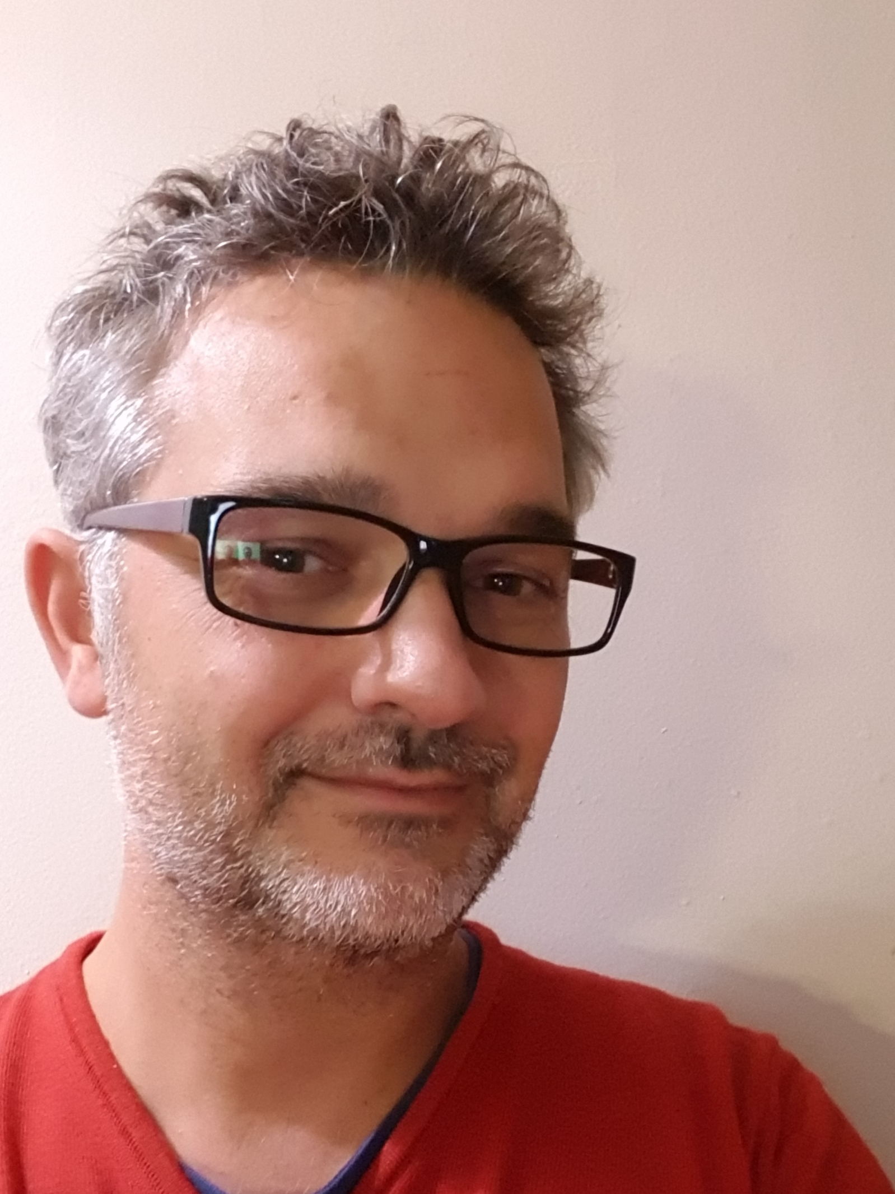

Luc PIATON

27/05/1977 › 40 years
married – 3 children
skype : luc.piaton
2 kerjagu
22200 PLOUISY
Tél. › +33 6 48 75 27 55
Email › luc.piaton972@gmail.com

« Travelling- it leaves you speechless, then turns you into a storyteller. »
Ibn Battuta (1304-1377) Moroccan Berber Explorer

RESUME

May I introduce myself in telling you that I'm a former French 40 years-old physical therapist, married with three children.

- Firstly I’m delighted to evoke with you my professional training:
I pass a high school diploma in sciences and my driving licence concomitantly in 1995. My driving lessons were a breath of fresh air during this stressing period.
Then I spend 4 memorable years in High School of Physiotherapy. I had a success in my final examination and became directly a physiotherapist on my own in 1999.
This job is in constant move so I choose to specialize my career in neuropediatry with 2 years of additional training (2003-2004) in levels of neuromotricity evolution.
Considering the fact that physical therapist is a human body mechanic, and that’s essential to have more and more items in your toolbox to treat patients the better you can, I studied osteopathy during 2 years (2005-2007).
While theses trainings, I have the opportunity to become a volunteer on week-ends in “Baby in Water Association” and pass this teaching diploma. Then I ‘ve been able to guide parents for 5 years in the holding and manipulating of their child in such a calm and warm environment that’s water. It was a very instructive and fruitful time.
- Secondly I can explain my career pathway:
Just after my physiotherapist State Diploma, I ‘ve moved in a French West Indies island called Martinique for one year. This is where I spent a summer in teaching anatomy to sport teacher students and worked as a physiotherapist all around the island. A unique place to be and wonderful living environment.

Soon afterwards, in October 2001, I created with 2 physiotherapist partners a multidisciplinary healthcare "mother-and-child" centre which shelters other specialties such as speech therapy, osteopathy, preventive gymnastics prophylaxis and midwifery.
Involved in ADEPAFIN Network (association certificated in studying and preventing foetal diseases and their consequences around delivery time) I participated in the screening and treatment of very premature infants and worked in tandem with other rehabilitation centres in the area.

During this period I created and taught differents classes such as baby massage parents learning, breath school in particular for mucoviscidosis children, training for prematured children’s parents and backaches muscular exercices classes.

Moreover in early 2017, I ‘ve participated in anatomy physical therapist exam Jury in Rennes’ Physiotherapist School. It was intense to be on the other side of the board: respect, relax, correct and use pedagogy with students.
As far as I can remember helping those in need has always been a thread in my professional career.

- Thirdly may I talk about my personal skills and passions:
I may confess that I love English culture and speaking. I explore a bunch of personal types of learning. Therefore I’m a multitask person, I spend time in crafting, driving or swimming while listening to English podcasts. My secret pleasure is to watch US tv series in original subtitled in English version. The more I spend time on my couch the better I learn some vocabulary. That’s a thing. Otherwise last year when I began my professional reconversion I took TOEIC and have proficient score (795/990).
In addition I’m keen on New Techs, IT and digital drawing. I spend so much time on tutorials and e-learning platforms with my graphic tablet to learn on Photoshop and Sketchbook.
At the moment I’m a daddy-at-home and I ‘ve created a graphic, second-level humor blog on the subject: www.peredeborde.com
Finally, I love to travel half on googlemap in my bed and half in real life with my family and my campervan. In 2014, we had a 5 months-5 persons trip to the edges of Europe with this vehicule. 13 countries and 13000 kms. A journey settled with numbers. My wife and I had 3 roles: parents, teachers and drivers for our 3 children . We shared plenty of magic moments all together and made so lovely and rare meetings. I‘m persuaded that we have so much to learn especially from Albanian and Slovenian culture, behaviours and way-of-living.

- To conclude: my future projects:
At 40 here I am at the crossroads. After health issues, I finally see a world of opportunities spreading in front of me. I’ve always kept in mind a liberal culture of not standing and waiting for the job to come to me, I’ve always built it up. As far as I am concerned I’m fond of neurology and by extention neurosciences and neuroergonomy. Theses sciences emerged from confidentiality essentially thanks to the popularization of fMRI (f for functional). That’s the reason why I’d like to gather this world with the e-learning one in creating my own company, which would propose and sell in BtoB digital learning and e-learning courses optimized by 20 years of neuroergonomy enhancement knowledges.

