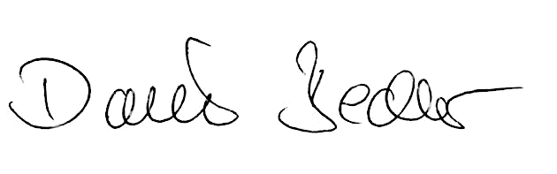

Zaccaro, Hervé
Advendi
Roland Keiser Daniel Bechler
Chief Technology Officer Head of Service
Philippsburg, 18.06.2013
SeeTec AG
SeeTec AG
confirms that
Mrs./Mr.:
employed by the company:
located in:
Certificate
Route de Salon - CS30093
13752 Les Pennes Mirabeau
France

successfully passed the „Certified Partner“ training in
June 2013. She/he is now official

„SeeTec Certified Partner“

for Full IP Video Management. This certification is valid

until 30.06.2014.
